**Create Windows Server Virtual Machine using PowerShell**

**Step 1:** Download **PowerShell package** from below link:

<https://azure.microsoft.com/en-us/downloads/?sdk=net>

Scroll down and navigate to **Command-line tools** section. Click on **Windows Install** under **PowerShell**.

It will download one online installer.

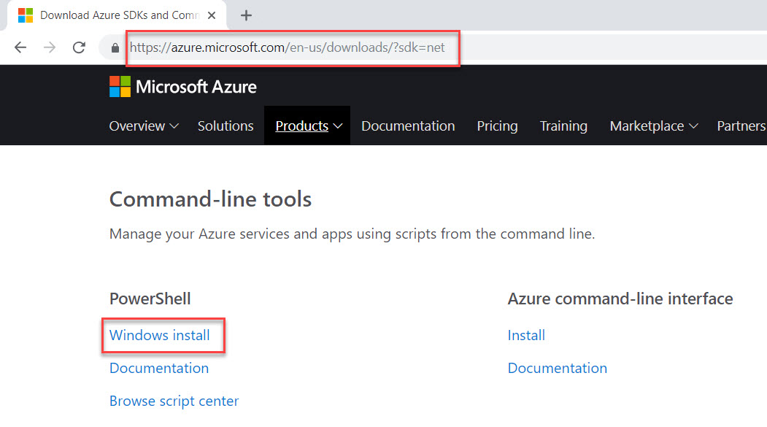

**Step 2:** Run the setup and click on **Install** button.

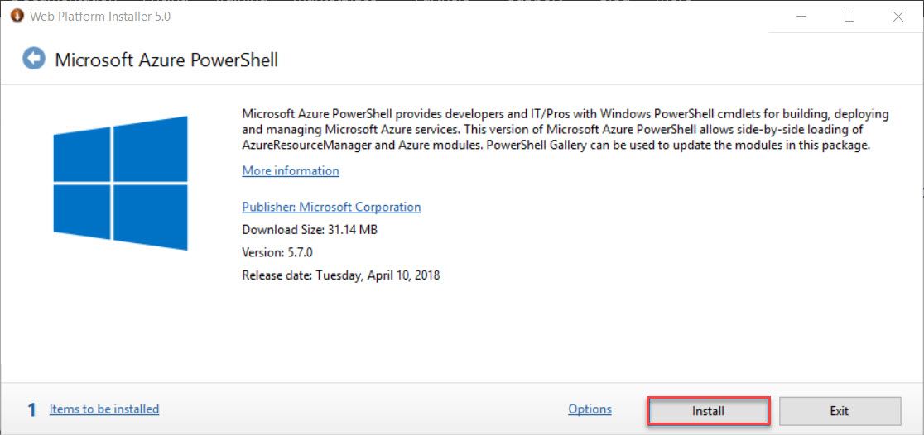

**Step 3:** Click on **Windows** button & search for **powershell**.

Click **Windows PowerShell**

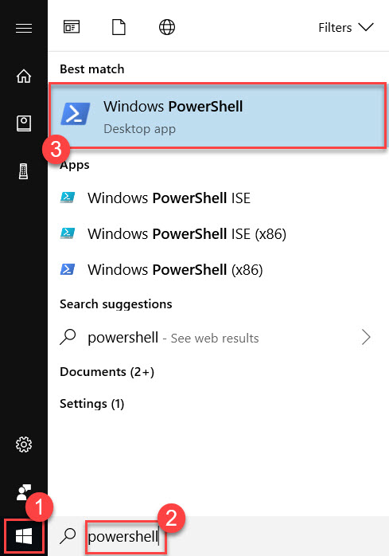

**Step 4:** PowerShell available on local machine so we need to connect Microsoft Azure account to local machine via PowerShell using below command:

Login-AzureRmAccount or *Connect-AzureRmAccount*

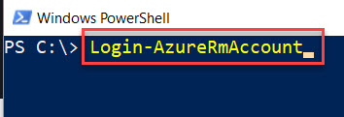

Enter Microsoft Azure Account Credentials

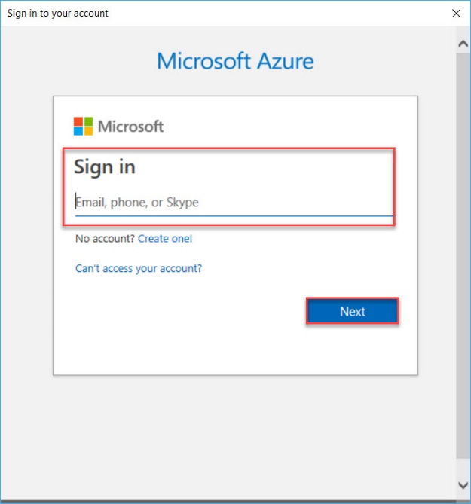

Account Details will load as below

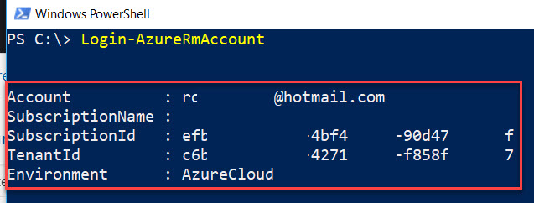

**Step 5:** List all Azure Subscription associated with email id.

*Get-AzureRmSubscription*

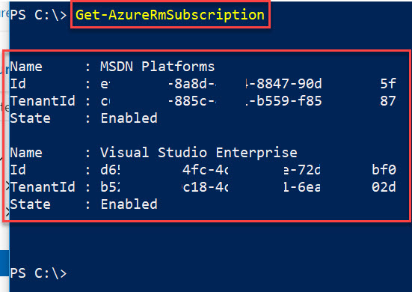

**Step 6**: if multiple Azure subscription associated with account need to select subscription as default

*Select-AzureRmSubscription -SubscriptionId ‘amciw4j-84oejjd-383ks-3jkskd84jfoqlf’*

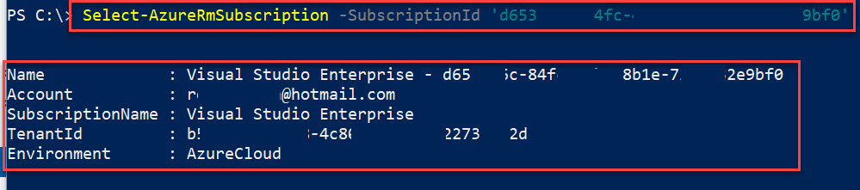

It will select as default

**Step 7:** First we need to create **Resource Group**

*New-AzureRmResourceGroup -Name myResourceGroup -Location SoutheastAsia*

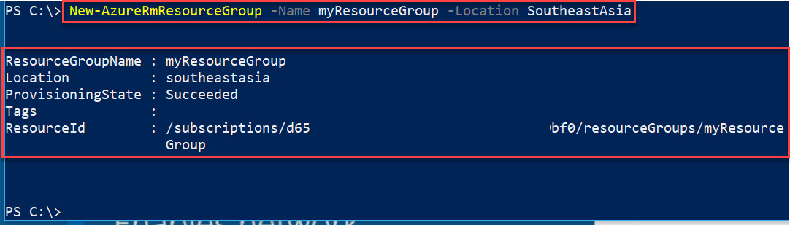

**Step 8:** Create **Virtual Machine** under same resource group

*New-AzureRmVm `*

*-ResourceGroupName "myResourceGroup" `*

*-Name "myVM" `*

*-Location "Southeast Asia" `*

*-VirtualNetworkName "myVnet" `*

*-SubnetName "mySubnet" `*

*-SecurityGroupName "myNetworkSecurityGroup" `*

*-PublicIpAddressName "myPublicIpAddress" `*

*-OpenPorts 80,3389*

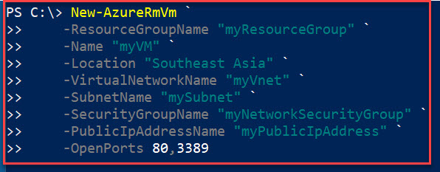

Enter New Username & Password

**Username:** demouser

**Password:** Demouser123

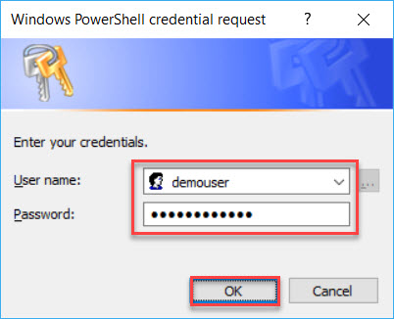

**Step 9:** After entering credentials, Virtual Machin will create.

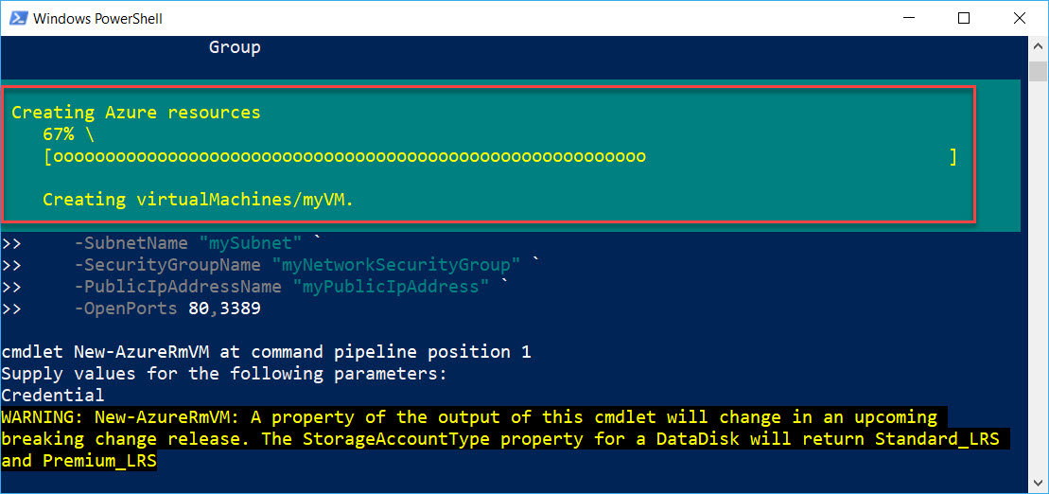

Wait for couple of minutes to deploy virtual machine.

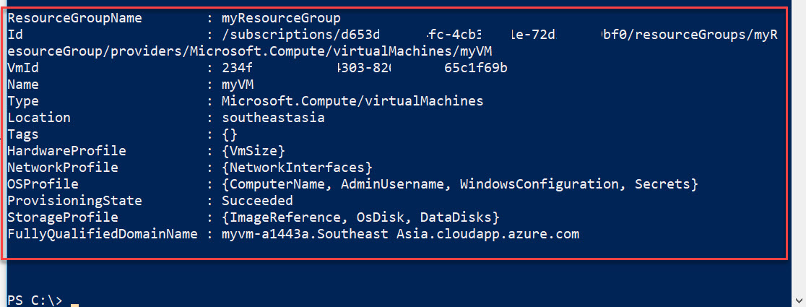

**Step 10:** To get Virtual Machine IP Address run below command

*Get-AzureRmPublicIpAddress -ResourceGroupName "myResourceGroup" | Select "IpAddress"*

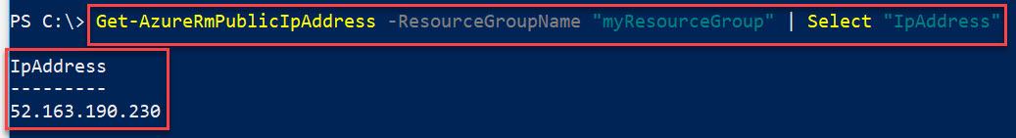

**Step 11:** Next step is to start Remote Desktop of that Virtual Machine

*mstsc /v:PublicIPAddress*

Ex. mstsc /v:52.163.190.230

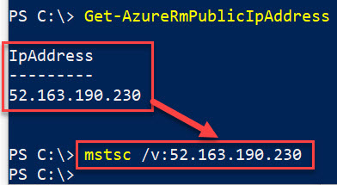

**Step 12:** Enter Virtual Machine credentials

**Username:** demouser

**Password:** Demouser@123

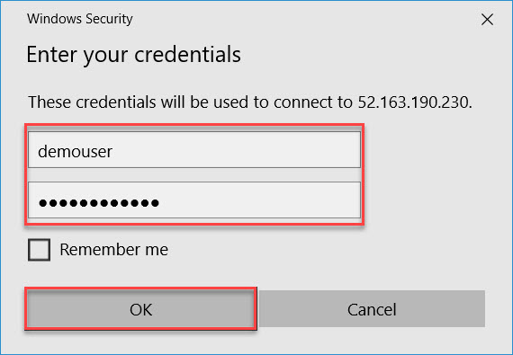

Click on **Yes** button.

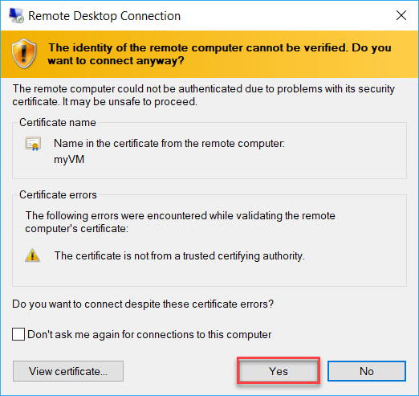

**Step 13:** Windows Server 2016 Virtual Machine will start.

Click on **Windows** button.

Right click on **Windows PowerShell** -> **More** -> **Run as administrator**

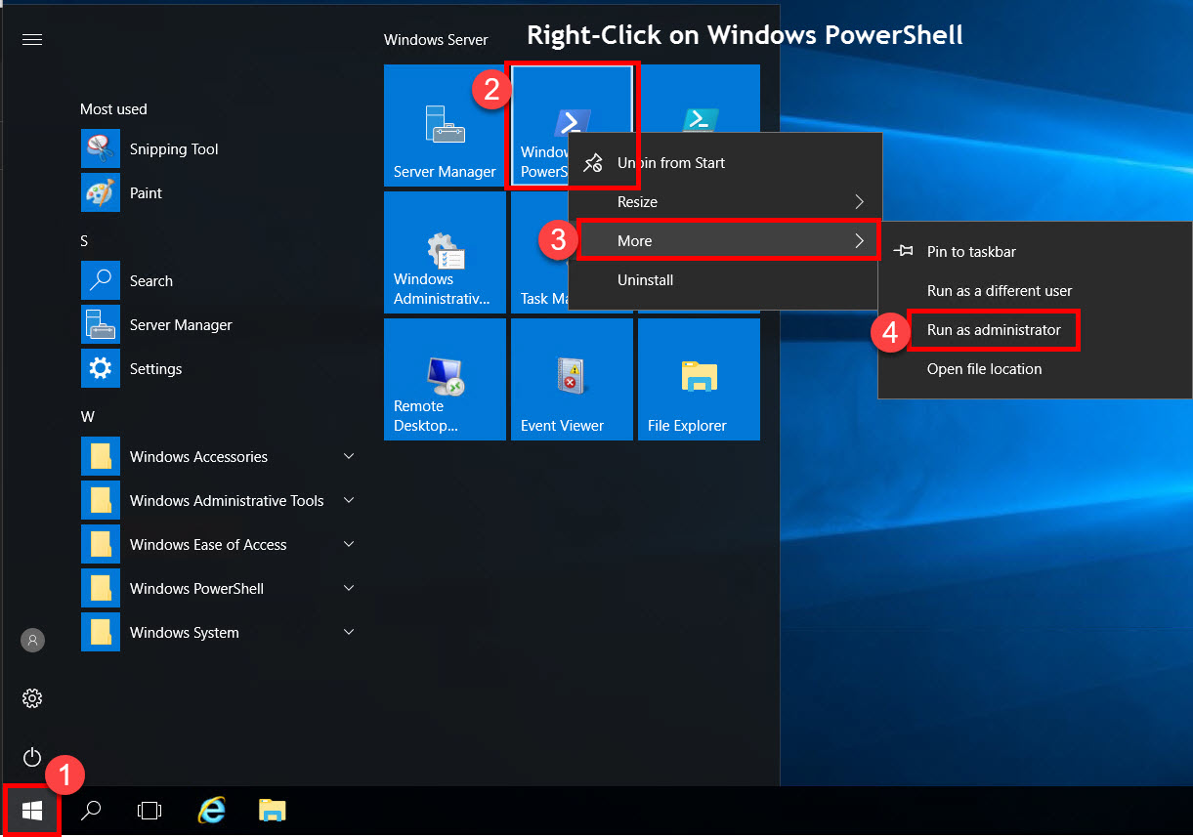

**Step 14:** Now we need to configure Web Server so we can host any website.

*Install-WindowsFeature -name Web-Server -IncludeManagementTools*

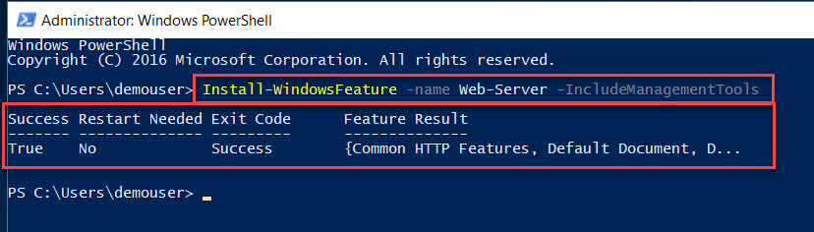

After installation close all the windows

**Step 15:** Open browser and type **Public IP Address**

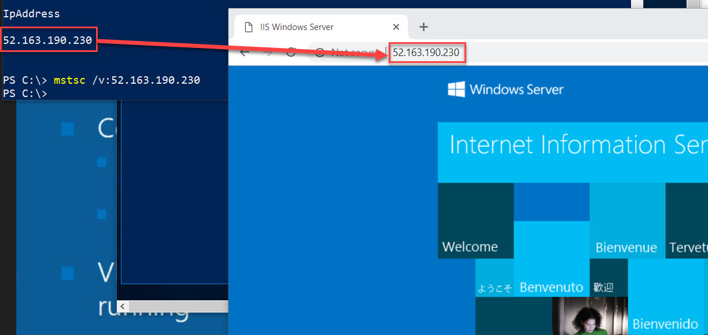

**Step 16:** Delete **Resource group**

*Remove-AzureRmResourceGroup -Name myResourceGroup*

